Lab10 CIS43 Due: 7/18/2016

Name: Nikhil Vytla

***Exercise: Ex 11.18***

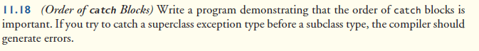

CompilerError

package P1118;

import java.util.InputMismatchException;

import java.util.NoSuchElementException;

public class CompilerError

{

public static void main(String[] args)

{

try //empty try block

{

}

catch (Exception e)//SUPERCLASS Exception Type

{

}

catch (InputMismatchException inputMismatchException)//SUBCLASS Exception Type

{

}

catch (ArithmeticException arithmeticException)//SUBCLASS Exception Type

{

}

catch (NoSuchElementException noSuchElementException)//SUBCLASS Exception Type

{

}

}

}

